**KIET Group of Institutions, Ghaziabad**

***Computer Science and Information Technology***

**Project Based Learning**

**on**

**TIC-TAC-TOE using C**

**SUBJECT: Data Structures using C**

**(KCS-351)**

**Submitted By:**

**SAYED OMAR AABID (2100290110149)**

**SHIV SHEKHAR (2100290110154)**

**SHIVAM YADAV (2100290110156)**

**About Project**

**Title of the project- Tic Tac Toe Game**

We were doing a project "A tic tac toe game (single player)"which is invented in ancient Egypt invented by Romans. It is played by two players.

A game of tic-tac-toe using a user-defined type (Struct) for the gameboard.

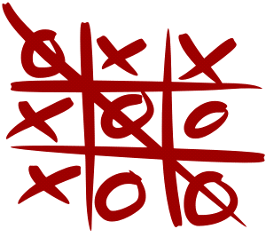The user needs to give input in form of row and column. Computers generate its random by using srand function in c which is used to generate random numbers and then using its remainder when divisible by 3 as position of 2D array.

**Technology Used:**

* Overview of C language.
* Algorithm used in C languages
* Working with visual studio compiler.
* Data Structures

**Features:**

* Teaches strategy skills.
* Develops logical thinking.
* Improves the ability to concentrate and focus.
* Teaches good sportsmanship.
* Sets the foundation for learning more complex games.
* Provides a simple and fun way for the family to bond.
* Develops problem-solving skills.
* Teaches patience (and turn-taking)

**Description**

We were doing a project "A tic tac toe game (single player)"which is invented in ancient Egypt invented by Romans. It is played by two players.

A game of tic-tac-toe using a user-defined type (Struct) for the gameboard.

The user needs to give input in form of row and column. Computers generate its random by using srand function in c which is used to generate random numbers and then using its remainder when divisible by 3 as position of 2D array.

**Problem Statement:**

This is a project-based course for beginners to have knowledges about the C programming language.  
This course is for the students who have zero experience in the programming field. The course is replete with quizzes and exercises that help with understanding the theoretical and practical aspects of C language. We were allotted a task to make a mini project using C language with additional activities like quizzes and making daily log report

**Proposed Solution:**

The player who succeeded in placing three respective marks in a horizontal, vertical, or diagonal row wins the game.

**Conclusion**

Data structure is most useful for applications that require the ability to be light-weight and have precise control over system resources. Using C, we can create lot of programs of embedded system due to its property of being light weight and precise control. You can also solve many real-life problems in C language. Tic Tac toe is a game created in C language using data structure.